Task 16: IAM overview
1. Log in to the AWS Management Console and navigate to the IAM dashboard; take a screenshot of the Users section showing the default view.
Ans
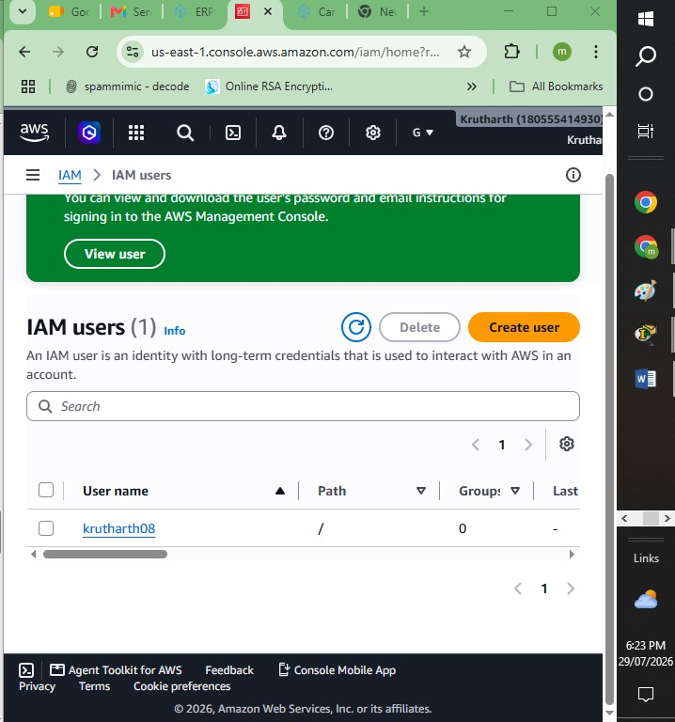
2. Create a new IAM user named InstaUploader and assign programmatic access only. Download the access key file and note where you saved it.<br><br><em><strong>Hint:</strong> Do not attach any permissions yet—just create the user and save the credentials.</em>
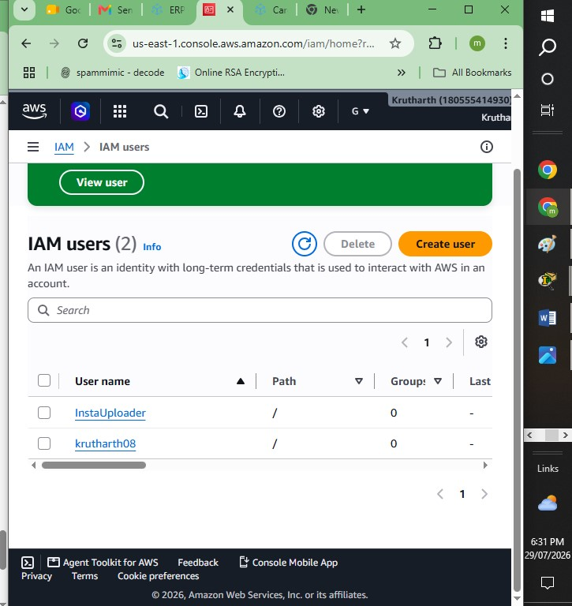
3. Create a group called ContentCreators in IAM, then add the InstaUploader user to this group.
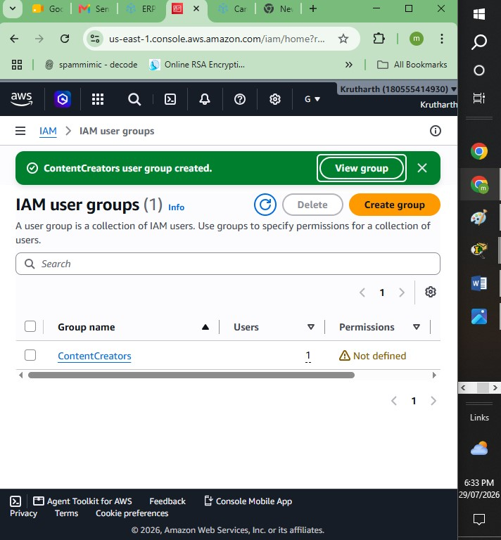
4. Write a short explanation (3-4 lines) describing the difference between an IAM user and an IAM role, using an example from any app you use daily (e.g., Zomato delivery agent vs. Zomato app admin).
Ans: An IAM User is a permanent identity in AWS that is created for an individual person or an application. It has long-term credentials, such as a username, password, and access keys, which are used to access AWS resources. Permissions are assigned directly to the user or through groups.
An IAM Role is a temporary identity that does not have permanent credentials. Instead, it provides temporary security credentials to trusted users, applications, or AWS services. Roles are assumed only when needed and are commonly used to allow AWS services or external users to access resources securely.
Example (Zomato):
- A Zomato delivery agent has a personal login ID and password to access the delivery app. This is similar to an IAM User because it is a permanent identity assigned to one person.
- The Zomato application may need temporary permission to upload customer order images to Amazon S3. Instead of storing permanent AWS credentials, the application assumes an IAM Role, receives temporary credentials, performs the upload, and the credentials automatically expire afterward.

Key Differences
IAM User | IAM Role
Permanent identity for a person or application | Temporary identity that is assumed when needed
Uses long-term credentials (passwords and access keys) | Uses temporary security credentials
Assigned directly to users | Assumed by users, applications, or AWS services
Best for human users and applications requiring continuous access | Best for AWS services, cross-account access, and temporary access
Credentials remain valid until changed or deleted | Credentials automatically expire after a limited time

